
www.womaenscaucus.org womaenscaucuscob@gmail.com
Womaen’s Caucus of the Church of the Brethren
www.womaenscaucus.org
womaenscaucucob@gmail.com

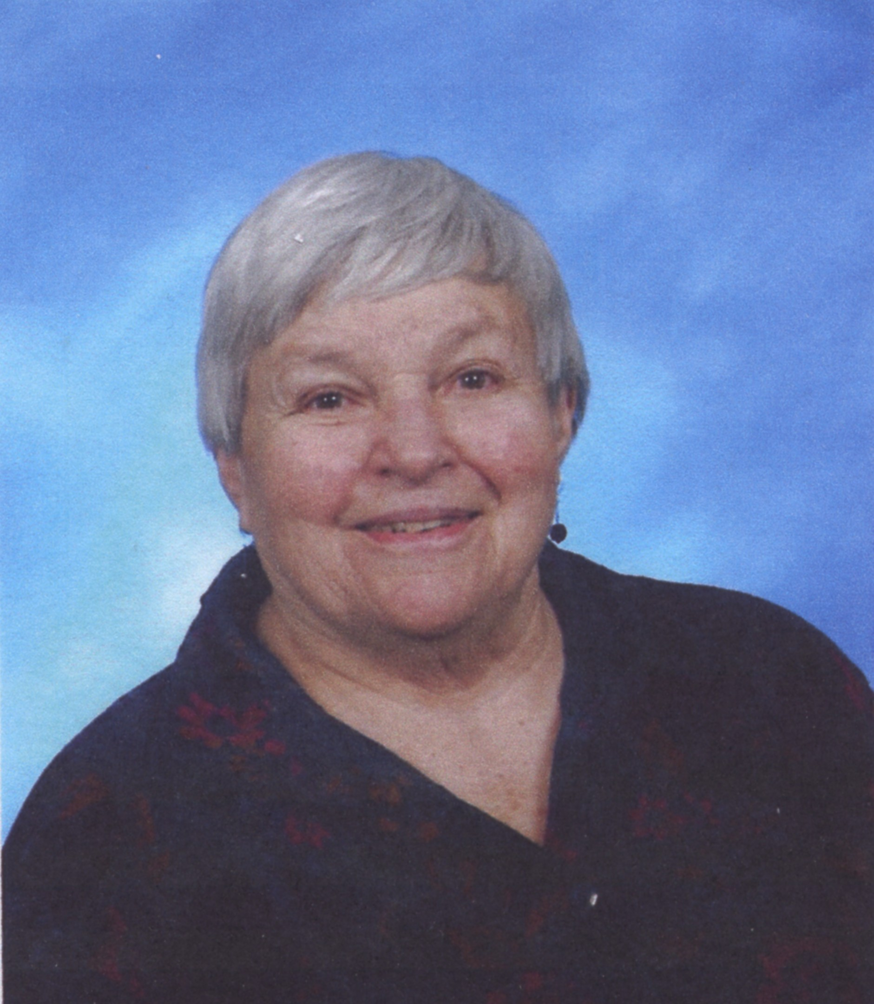
The Mary Blocher Smeltzer Scholarship
to Further the Leadership Development of Women

In March 1978, the Womaen's Caucus Steering Committee created a scholarship in honor of Mary Blocher Smeltzer, one of the founders of Womaen’s Caucus, to further the leadership development of women in the Church of the Brethren. The scholarship provides financial assistance to enable women to continue in the development of identified skills or to learn new ones. Womaen's Caucus believes that leadership takes place in many significant ways, including participation in workshops, training events, seminars, conferences, retreats, short courses, and other growth opportunities sponsored by the Church of the Brethren or other ecumenical or secular organizations. Funds do not allow allocation of scholarships for undergraduate or graduate course work.
Applications are considered and awards are made as they are received throughout the year. In order to assist as many women as possible, individuals may receive only one scholarship. To apply, you can download the application online in Word or pdf format and submit it by email to womaenscaucuscob@gmail.com or complete this form and mail it to:
Womaen’s Caucus
MBS Scholarship
818 SW 3rd Ave #1299
Portland OR 97204

Mary Blocher Smeltzer Scholarship Application
To apply, please fill out the following.

Name: |  |  | Email:
Address: |  |  | Phone:
Congregation: |  |  | District:

Names of two references | Phone Number |  | Total Cost  of activity | Amount You Are Applying For

Describe the leadership activity you plan to attend.
Which specific leadership skills will you focus on through this activity? How will your attendance develop these leadership skills?

The following is the Statement of Identity and Mission of Womaen’s Caucus:

Womaen’s Caucus is a network of feminist women and men emboldened by an awareness of the violence and pain related to the denial of gender equality. Empowered by the Holy Spirit, we speak to and act prophetically within the Church of the Brethren to break down attitudes and practices of injustice and inequality to create a church of welcome, justice, and peace for all.

How will your participation in this activity intersect with women’s issues / lives and advance the Mission of Womaen’s Caucus?

All scholarship recipients are required to creatively give back to the Caucus community and the women/girls of the church by creating some sort of resource(s) that can be used by part or all of the church. Some examples of resources based on your activity might include: worship resources or liturgies, Sunday school session or other curriculum for adults or youth, photographic journal with theological / social commentary publishable on the Caucus website, presentation at Caucus event, a short video suitable for YouTube or distribution on DVD, sermon, workshop offered, etc. We encourage you to use your imagination and get excited about what you can offer. Your resource must be received by Caucus within three months after you complete your leadership training activity unless you negotiate otherwise.

What resource(s) do you propose to create out of your training activity? Please describe what you wish to do in as much detail as possible.

If I am granted a Mary Blocher Smeltzer Scholarship, I agree to use the funds to complete the above described activity and to provide resource(s) back to Caucus within three months of my attendance at the event.

____________________________________________ __________________________
Signature Date

FOR CAUCUS USE ONLY:
Date Received: | Funding Granted:

