**The Mary Blocher Smeltzer Scholarship  
to Further the Leadership Development of Women**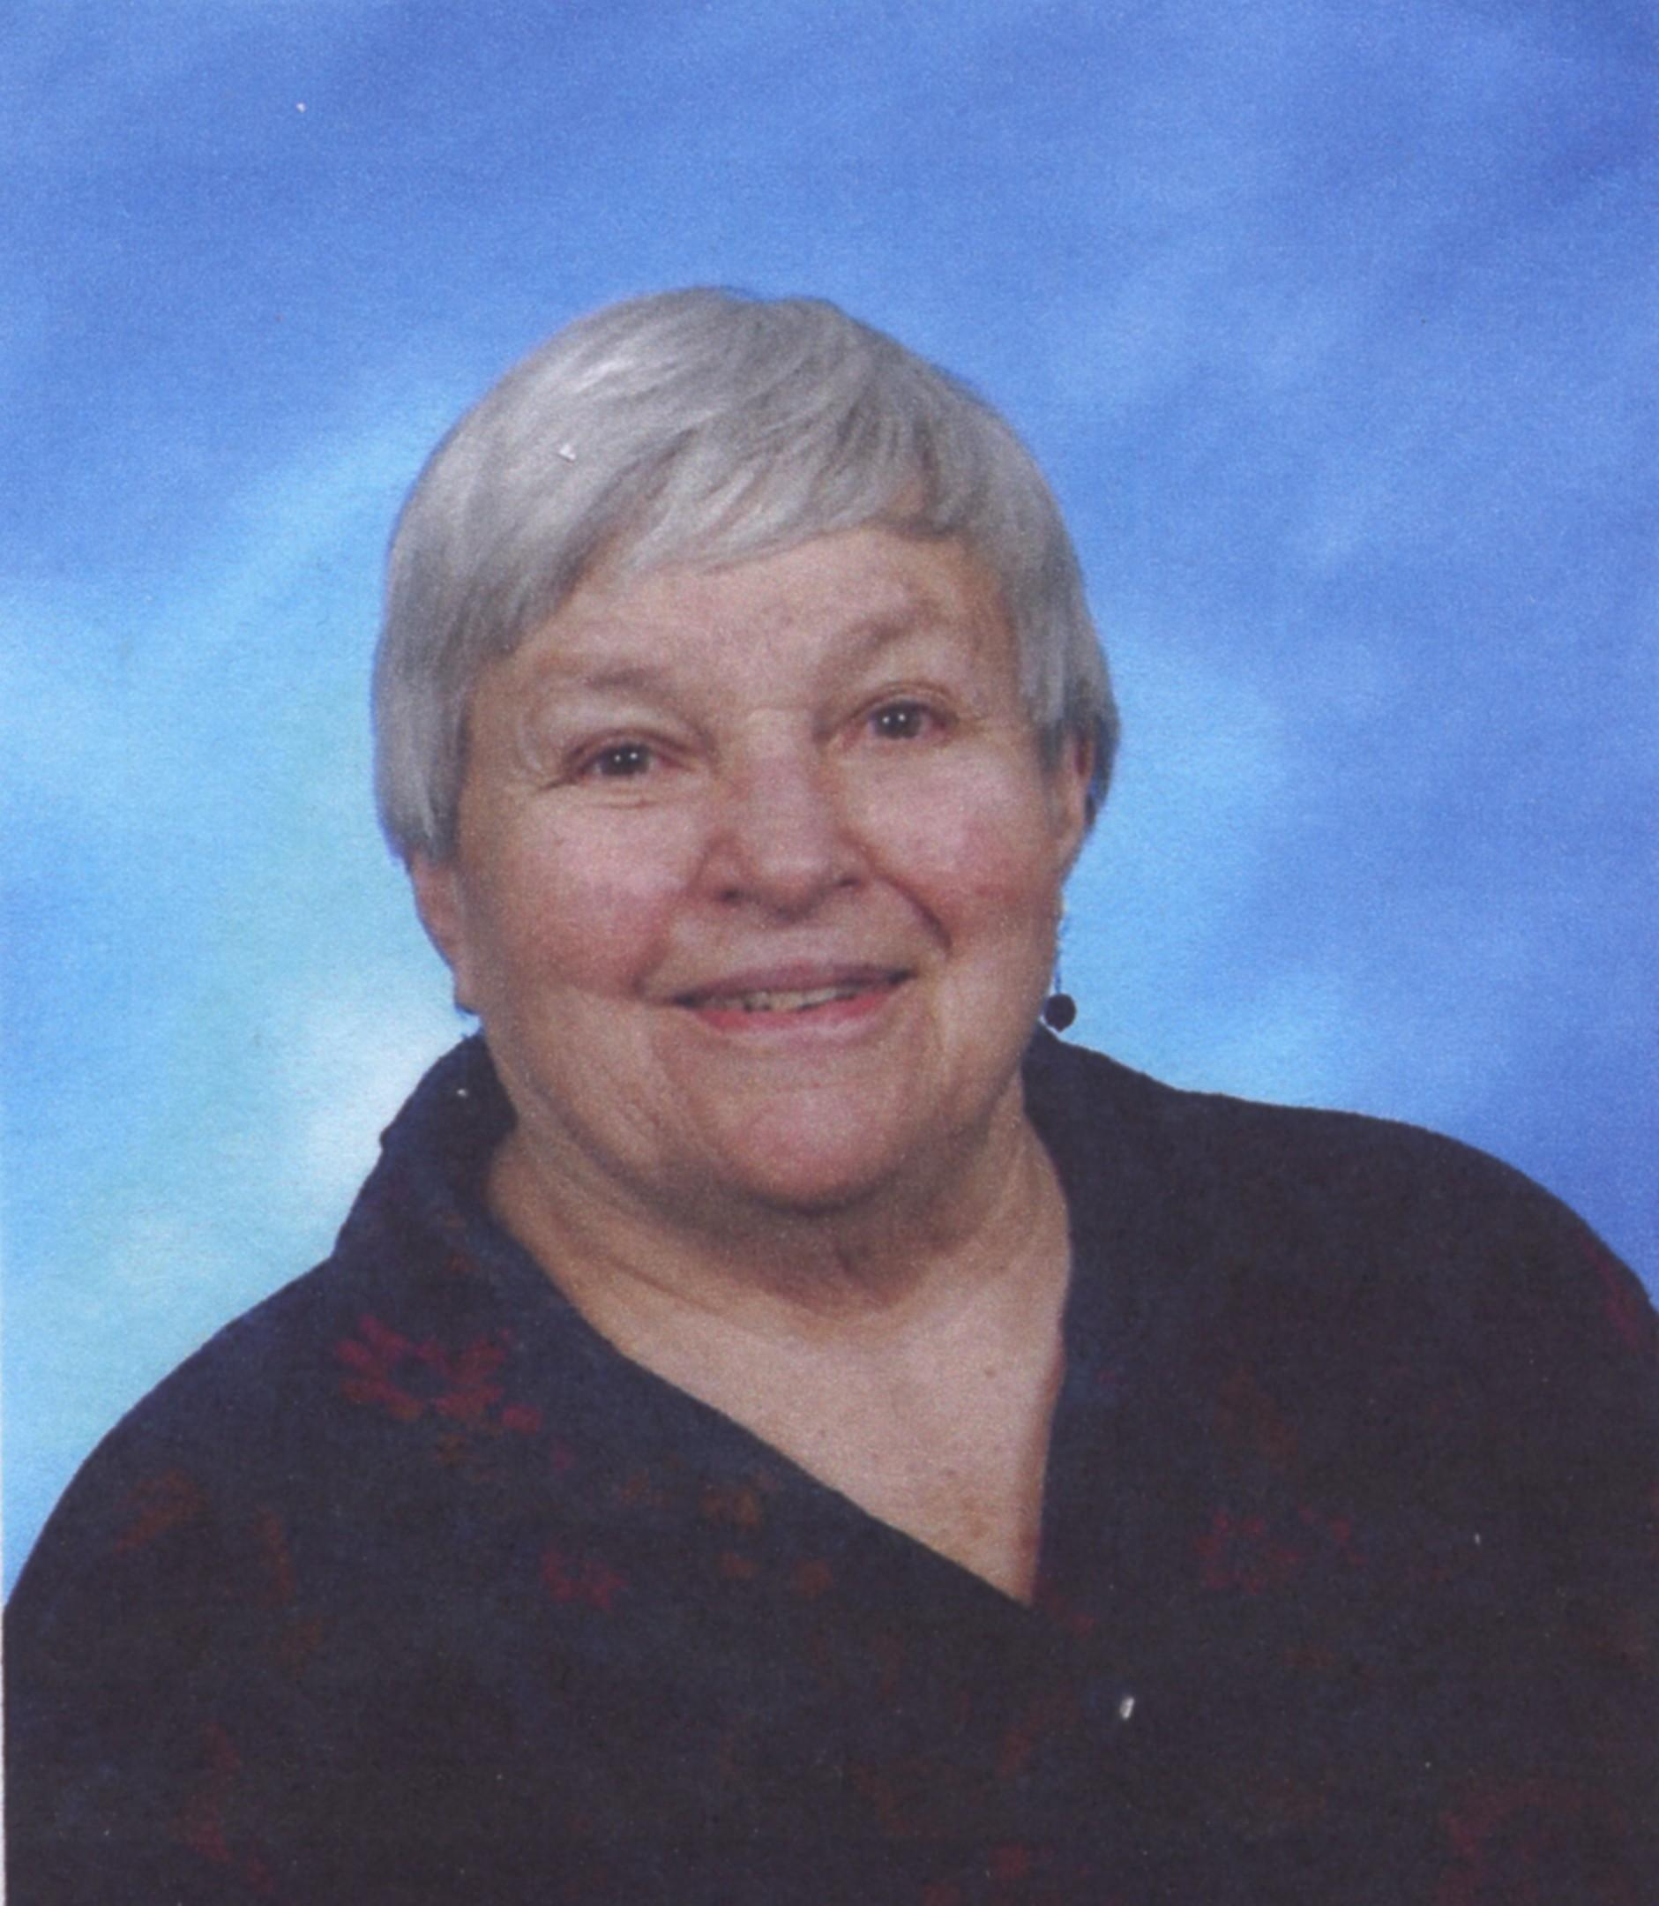

In March 1978, the Womaen's Caucus Steering Committee created a scholarship in honor of Mary Blocher Smeltzer, one of the founders of Womaen’s Caucus, to further the leadership development of women in the Church of the Brethren, including participation in workshops, training events, seminars, conferences, retreats, short courses, and other growth opportunities sponsored by the Church of the Brethren or other ecumenical or secular organizations. Funds do not allow allocation of scholarships for undergraduate or graduate course work.

Applications are considered and awards are made as they are received throughout the year. In order to assist as many women as possible, individuals may receive only one scholarship, up to $500. To apply, you can download the application online in Word or pdf format and submit it by email to [womaenscaucuscob@gmail.com](mailto:womaenscaucuscob@gmail.com) or complete this form and mail it to:

Womaen’s Caucus

MBS Scholarship

818 SW 3rd Ave #1299  
Portland OR 97204



**Mary Blocher Smeltzer Scholarship Application**

*To apply, please fill out the following.*

| **Name:** |  |  | **Email:** |  |
| --- | --- | --- | --- | --- |
| **Address:** |  |  | **Phone:** |  |
| **Congregation:** |  |  | **District:** |  |

| **Names of two references** | **Phone Number** |  | **Total Cost**  **of activity** | **Amount You Are Applying For** |
| --- | --- | --- | --- | --- |
|  |  |  |  |  |
|  |  |  |  |  |

**Describe the leadership activity you plan to attend.**

|  |
| --- |

**Which specific leadership skills will you focus on through this activity? How will your attendance develop these leadership skills?**

|  |
| --- |

**The following is the Statement of Identity and Mission of Womaen’s Caucus:**

Womaen's Caucus is a feminist network connected to the Church of the Brethren. We engage in the prophetic task of creating church which is free from attitudes and practices of injustice.

**How will your participation in this activity intersect with this mission?**

|  |
| --- |

All scholarship recipients are required to creatively give back to the Caucus community and the women/girls of the church by creating some sort of resource(s) that can be used by part or all of the church. Some examples of resources based on your activity might include: article for our Femailings newsletter, worship resources or liturgies, Sunday school session or other curriculum for adults or youth, photographic journal with theological / social commentary publishable on the Caucus website, presentation at Caucus event, short video testimony, sermon, workshop offered, etc. We encourage you to use your imagination and get excited about what you can offer. Your resource must be received by Caucus within three months after you complete your leadership training activity unless you negotiate otherwise.

**What resource(s) do you propose to create out of your training activity? Please describe what you wish to do in as much detail as possible.**

|  |
| --- |

**If I am granted a Mary Blocher Smeltzer Scholarship, I agree to use the funds to complete the above described activity and to provide resource(s) back to Caucus within three months of my attendance at the event.**

____________________________________________ __________________________

*Signature Date*

FOR CAUCUS USE ONLY:

| *Date Received:* | *Funding Granted:* |
| --- | --- |

